**Table 1- tbldvdtitles**

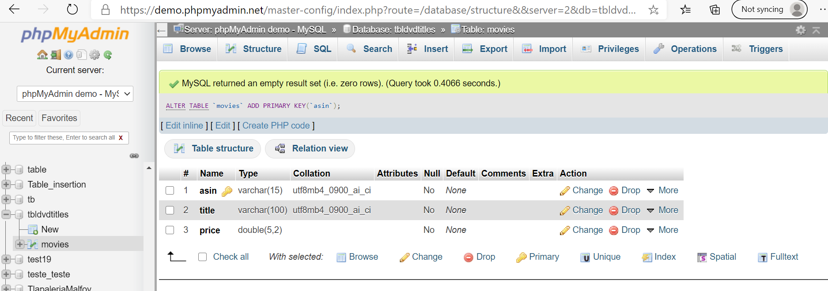

**Tblddvdtitles SQL statement**

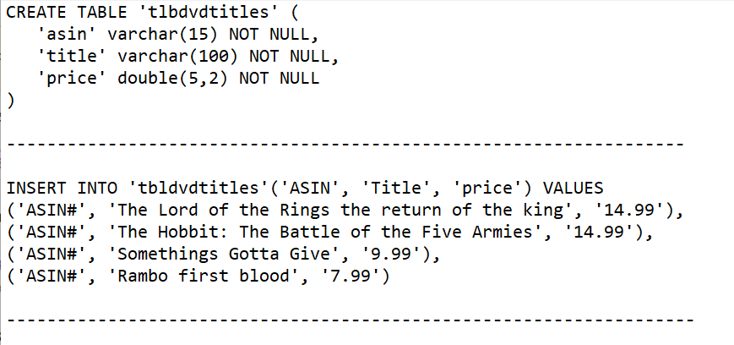

**Table 2- tbldvdActors**

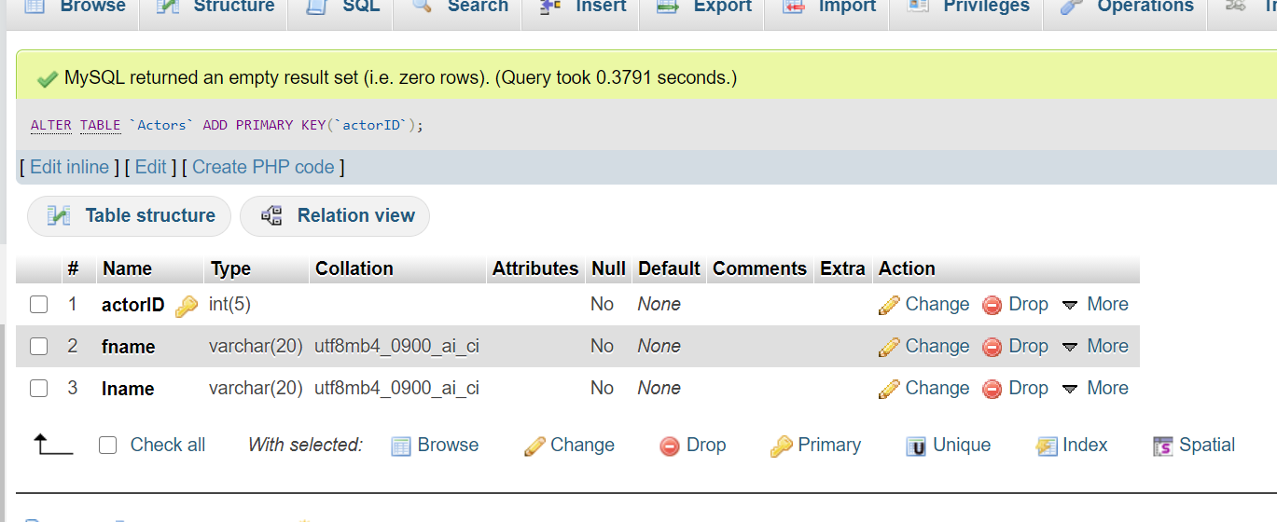

**tbldvdActors SQL statement**

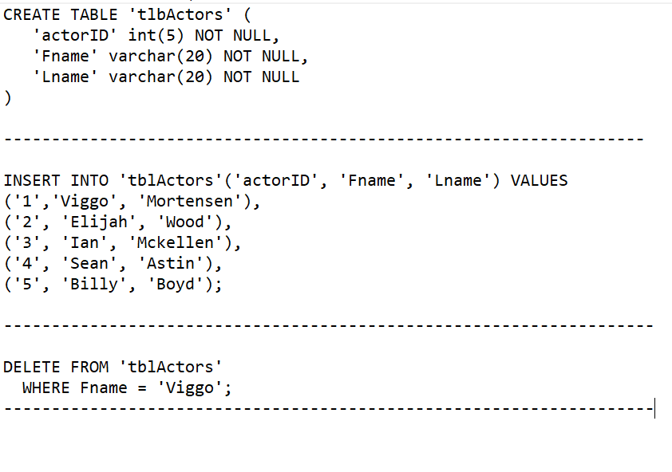

**Table 3- Relationships**

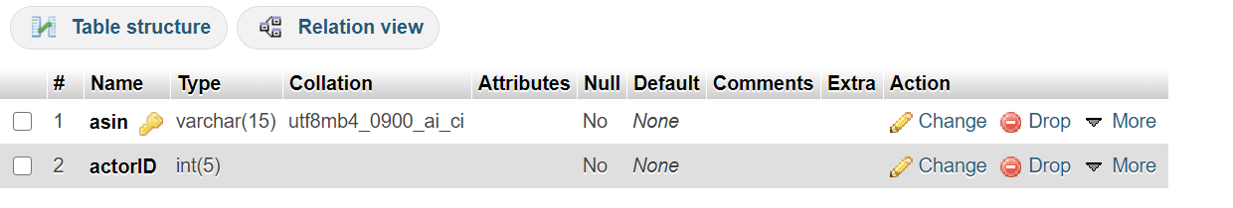

**Relationships**

